PRACTICE EXERCISE – 2
PROMPT GENERATION AND PROMPT REFINEMENT
Topic: Applications of Deep Learning in Healthcare

Designed with detailed theory, prompt refinement, analysis, diagrams and references.

Name: K. SUMANASRI
Register Number: 261FB04017
Programme: M. Tech
Branch: CSE
Subject: AI
Academic Year: 2026 – 2027
College/University: Vignan's Foundation for Science, Technology & Research (Deemed to be University)
Faculty Name: Mr Kahadersh
Date: 6-10-2026

1. AIM
To use an AI tool to generate content on Applications of Deep Learning in Healthcare, critically evaluate the first response, refine the prompt using explicit constraints, and compare the initial and improved outputs.
2. OBJECTIVES
- Understand how prompt wording affects AI-generated content.
- Create an initial zero-shot prompt for a technical topic.
- Identify missing requirements, ambiguity and weaknesses in the initial response.
- Refine the prompt by specifying role, audience, length, structure, technical scope and examples.
- Evaluate whether the refined response is more complete, relevant and academically suitable.
- Present the final result using clear headings, tables and diagrams.
3. TOOLS / REQUIREMENTS
- AI assistant such as ChatGPT or Gemini
- Microsoft Word / compatible document editor
- Web browser for reference material and online diagrams
- Internet connection
- Basic knowledge of Deep Learning and healthcare applications
4. INTRODUCTION TO DEEP LEARNING
Deep Learning (DL) is a subfield of Machine Learning that uses neural networks with multiple layers to learn hierarchical representations from data. Unlike many traditional machine-learning workflows that rely heavily on manually engineered features, deep networks can learn useful representations directly from large datasets. Modern deep learning became practical because of larger datasets, improved optimization methods, and high-performance computing such as GPUs.
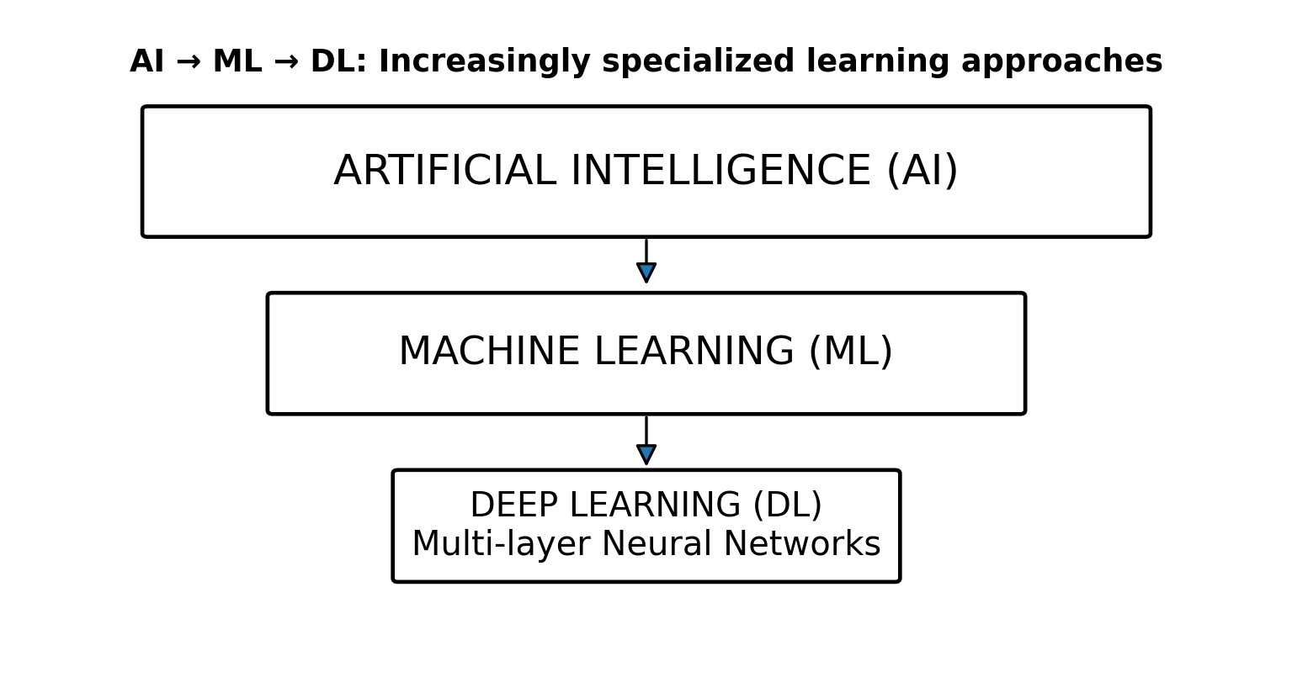
Figure 1. AI–ML–DL relationship (clean academic redraw based on standard deep-learning literature).
5. WHY DEEP LEARNING IS IMPORTANT IN HEALTHCARE
Deep Learning has become an important technology in healthcare because modern medical systems generate large, complex, and diverse amounts of data. Traditional methods may require experts to manually identify important features from this data, whereas deep learning models can automatically learn useful patterns and representations from large datasets. This makes deep learning particularly valuable for medical image analysis, disease prediction, patient monitoring, clinical text processing, drug discovery, and personalised medicine.
- Handling high-dimensional medical data: Healthcare data are often high-dimensional and multimodal. They include X-ray, CT scans, MRI scans, ultrasound images, pathology images, ECG signals, laboratory results, electronic health records (EHRs), medical reports, and clinical notes. Deep neural networks can process these different types of data and identify complex relationships that may be difficult to detect using conventional techniques.
- Automatic feature learning: One major advantage of deep learning is its ability to automatically learn relevant features from raw data. For example, in medical image analysis, a Convolutional Neural Network (CNN) can progressively learn features such as edges, textures, shapes, and complex anatomical patterns. This reduces the dependence on manually designed features and allows the model to learn task-specific representations from training data.
- Medical image analysis: Deep learning is widely studied for analysing medical images. It can support classification, detection, segmentation, and image-based prediction. For example, deep learning models can analyse X-ray or CT images to identify suspicious regions and can segment organs or lesions for further analysis. Such systems can assist radiologists and other healthcare professionals by providing additional information during image interpretation.
- Disease detection and prediction: Deep learning can be used to identify patterns associated with diseases and estimate the risk of developing certain medical conditions. By learning from historical patient data, models can support early risk assessment and help healthcare professionals identify patients who may require additional examination or monitoring.
- Patient monitoring: Healthcare devices continuously generate information such as heart rate, ECG signals, oxygen saturation, blood pressure, and other physiological measurements. Deep learning models can analyze these time-series data and identify unusual patterns or changes. This can support continuous patient monitoring and alert healthcare professionals when further assessment may be necessary.
- Clinical text processing: Hospitals produce large amounts of textual information, including medical reports, discharge summaries, clinical notes, and prescriptions. Deep learning and Natural Language Processing (NLP) models can help extract useful information, classify documents, summarize relevant information, and support clinical information retrieval.
- Drug discovery and development: Deep learning can also contribute to pharmaceutical research. Models can analyze molecular structures and biological datasets to predict molecular properties and help researchers prioritize promising drug candidates. This can potentially reduce the time and resources required during some stages of drug discovery.
- Personalized healthcare: Patients can respond differently to treatments. Deep learning can combine multiple types of patient information to identify patterns that may support more personalized risk assessment and treatment planning. However, such systems require careful validation before being used in real clinical environments.
- Support for radiology and clinical decision-making: In radiology, deep learning has been investigated for lesion detection, image classification, segmentation, image reconstruction, monitoring, and prediction of treatment response. These systems are generally intended to support healthcare professionals rather than replace them. The final clinical decision should remain under appropriate professional supervision.
- Improved efficiency: Deep learning can automate or accelerate repetitive data-analysis tasks. This may help healthcare professionals process large datasets more efficiently and focus their time on complex cases, patient interaction, and clinical decision-making.
- Need for responsible implementation: High predictive accuracy alone does not guarantee that a healthcare AI system is reliable. Data quality, patient privacy, security, bias, fairness, interpretability, external validation, clinical validation, and workflow integration are important considerations. A model trained on data from one hospital or population may not perform equally well in another environment.
6. STEP 1 – INITIAL PROMPT
Initial prompt given to the AI tool:
“Write about Deep Learning in Healthcare.”
7. AI OUTPUT – INITIAL RESPONSE
Deep Learning is a subset of machine learning that uses neural networks with multiple layers to learn patterns from large amounts of data. In healthcare, deep learning can analyze medical images, assist in disease diagnosis, predict patient risks, monitor patients, and support drug discovery. CNNs are commonly used for image analysis, while other neural-network architectures can process sequential and clinical data. Deep learning can improve efficiency, but challenges include data privacy, bias, interpretability, validation, and the need for large amounts of high-quality data.
8. ANALYSIS OF THE INITIAL PROMPT
- Too broad: it does not define the exact learning outcome.
- No audience: the response may not match M.Tech CSE academic expectations.
- No word limit: output length can vary considerably.
- No structure: important sections may be omitted.
- No model coverage: CNN, RNN/LSTM and Transformer roles are not explicitly requested.
- No application depth: examples are mentioned but not explained.
- No evaluation criteria: advantages, limitations, ethics and deployment are not systematically covered.
- No formatting requirements: the answer may not look like a proper academic experiment.
9. WHAT MAKES A STRONGER PROMPT?
- Role: tell the AI to respond as an academic/technical writer.
- Audience: specify M.Tech CSE students.
- Task: clearly state that the output is an academic explanation.
- Scope: identify the exact models and applications to cover.
- Constraints: specify approximate word count and what must be included.
- Format: specify headings, tables, bullet points and conclusion.
- Quality criteria: request technically accurate, non-repetitive and logically organized content.
- Examples: request practical healthcare examples.
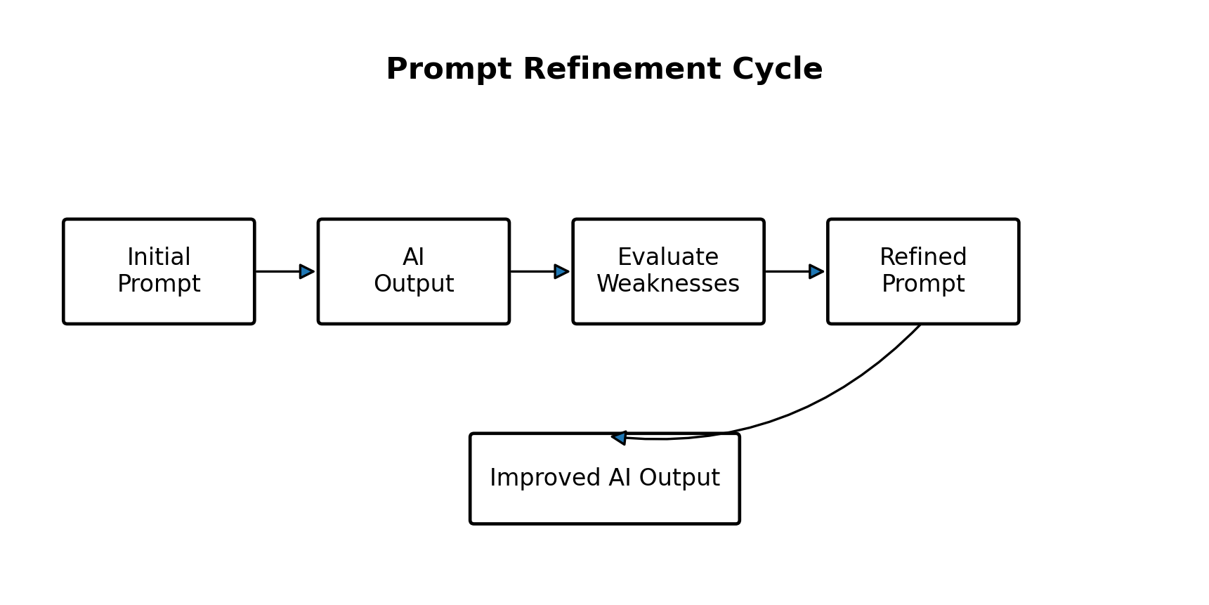
Figure 2. Prompt refinement cycle used in this experiment.

10. STEP 2 – REFINED PROMPT
“Act as an academic technical writer for M.Tech CSE students. Write an approximately 900-word structured explanation on ‘Applications of Deep Learning in Healthcare’. Organize the response using these headings: 1) Introduction, 2) Why Deep Learning is Suitable for Healthcare Data, 3) CNN, RNN/LSTM and Transformer Models, 4) Medical Image Analysis, 5) Disease Prediction and Risk Assessment, 6) Patient Monitoring, 7) Drug Discovery and Development, 8) Clinical Text and Decision Support, 9) Advantages, 10) Challenges and Ethical Issues, 11) Future Scope, and 12) Conclusion. Explain each major application with a practical example. Include a compact comparison table of the models and applications. Use clear academic language, avoid unnecessary repetition, and distinguish AI assistance from final clinical decision-making. Include a short end-to-end workflow from data collection to validation and deployment.”
11. WHY THIS PROMPT IS BETTER
Prompt Element | Initial | Refined
Role | Not specified | Academic technical writer
Audience | Not specified | M.Tech CSE students
Length | Not specified | ~900 words
Structure | Open-ended | 12 specified sections
Models | General | CNN, RNN/LSTM, Transformer
Applications | General list | Five detailed areas
Examples | Not requested | Practical example per application
Quality | No criteria | Clear, academic, non-repetitive
Workflow | Not requested | End-to-end workflow
Ethics | Brief mention | Dedicated section
12. EXPECTED IMPROVEMENT
The refined prompt reduces ambiguity and increases controllability. It tells the AI what to write, for whom, how much to write, which technical concepts to cover, how to organize the response, and what quality constraints to follow. Therefore, the second response should be more useful as an academic submission than the initial response.

13. AI OUTPUT – IMPROVED RESPONSE
13.1 Introduction
Deep Learning is a machine-learning approach based on neural networks with multiple layers. It is well suited to healthcare because healthcare generates large volumes of complex data, including medical images, physiological signals, clinical text and electronic health records. Deep learning can learn representations from these data and support tasks such as classification, detection, segmentation and prediction. It should be treated as a decision-support technology and not as an automatic replacement for qualified clinical judgment.
13.2 Why Deep Learning is Suitable for Healthcare Data
Healthcare datasets often contain spatial, temporal and textual patterns. CNNs are effective for spatial patterns in images; RNN/LSTM models can represent sequential information; and Transformer-based architectures can model long-range relationships in text and multimodal data. Transfer learning and data augmentation can also be useful when labelled medical datasets are limited.
13.3 CNN, RNN/LSTM and Transformer Models
CNNs learn local spatial features through convolution and pooling operations and are widely used for medical image classification, detection and segmentation. RNNs and LSTMs were designed to process sequences and can be applied to time-dependent patient information. Transformers use attention mechanisms to model relationships across sequences and are increasingly relevant to clinical language and multimodal applications.
13.4 Medical Image Analysis
Medical image analysis is one of the most established deep-learning application areas. Systems can classify images, detect abnormalities, segment organs or lesions, and support quantitative analysis. Examples include analysis of X-rays, CT, MRI, pathology images and medical photographs. A typical workflow includes image acquisition, preprocessing, dataset splitting, model training, validation, testing and clinical evaluation.
13.5 Disease Prediction and Risk Assessment
Deep learning can combine demographic, laboratory, imaging and longitudinal information to estimate risk or identify patterns associated with disease. Such systems may support earlier identification of high-risk patients. However, performance must be evaluated on representative external datasets and should not be assumed to generalize automatically to every hospital or population.
13.6 Patient Monitoring
Continuous physiological data such as heart rate, oxygen saturation, ECG signals or other sensor measurements can contain temporal patterns. Deep learning models can help identify abnormal trends or events and provide alerts for further clinical review. The quality of monitoring depends on sensor reliability, missing data handling, false-alarm management and appropriate clinical integration.
13.7 Drug Discovery and Development
Deep learning can be applied to molecular representations, chemical structures and biological data to estimate properties, prioritize candidate molecules and support parts of the drug-development pipeline. These models can reduce the search space for researchers, but laboratory experiments and clinical trials remain necessary before medical use.
13.8 Clinical Text and Decision Support
Natural-language models can process clinical notes, reports and other text to extract information, classify documents, summarize content or support information retrieval. Decision-support systems must be carefully validated because errors in clinical language processing can have significant consequences.
13.9 Advantages
Major advantages include automated feature learning, ability to process large datasets, strong performance on image and pattern-recognition tasks, scalable analysis and potential support for personalized healthcare. Deep learning can also reduce repetitive manual analysis in selected workflows.
13.10 Challenges and Ethical Issues
Key challenges include limited or biased datasets, privacy and security, explainability, domain shift between hospitals, annotation cost, computational requirements, calibration, fairness and clinical validation. A model that performs well on one dataset may perform differently in another clinical environment. Responsible deployment therefore requires governance, monitoring and human oversight.
13.11 Future Scope
Future work is likely to emphasize multimodal models, federated learning, self-supervised learning, efficient models for resource-constrained environments, explainable AI, uncertainty estimation and better integration with clinical workflows. These directions aim to improve robustness, privacy, generalization and practical usefulness.
13.12 Conclusion
Deep Learning provides a powerful set of methods for healthcare applications, especially medical image analysis, prediction, monitoring, drug discovery and clinical text processing. Its value is highest when technical performance is combined with high-quality data, rigorous validation, privacy protection, fairness, interpretability and responsible clinical oversight.
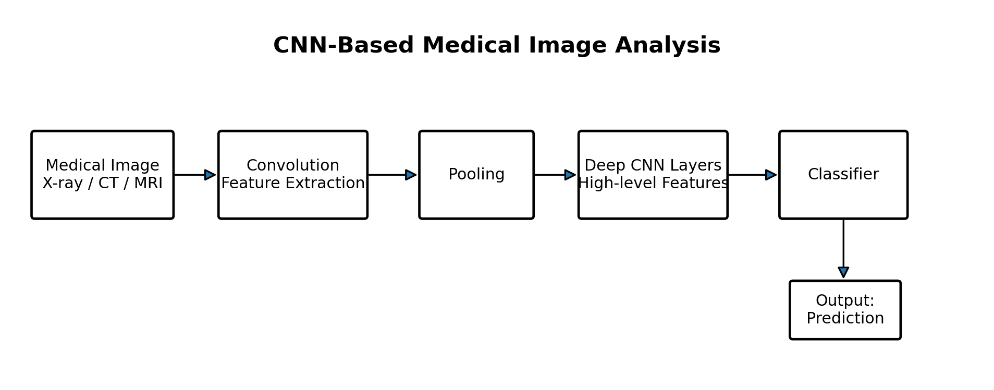
Figure 3. CNN-based medical image analysis pipeline (exam-friendly redraw).
Online source: European Society of Radiology, “Deep learning workflow in radiology: how to get started.”

14. END-TO-END HEALTHCARE DEEP LEARNING WORKFLOW
A reliable healthcare deep-learning system is not only a neural network. It is a pipeline that starts with data acquisition and curation and continues through preprocessing, training, validation, testing, clinical evaluation and deployment. The workflow should include appropriate data governance and anonymization, and the model should be monitored after deployment.
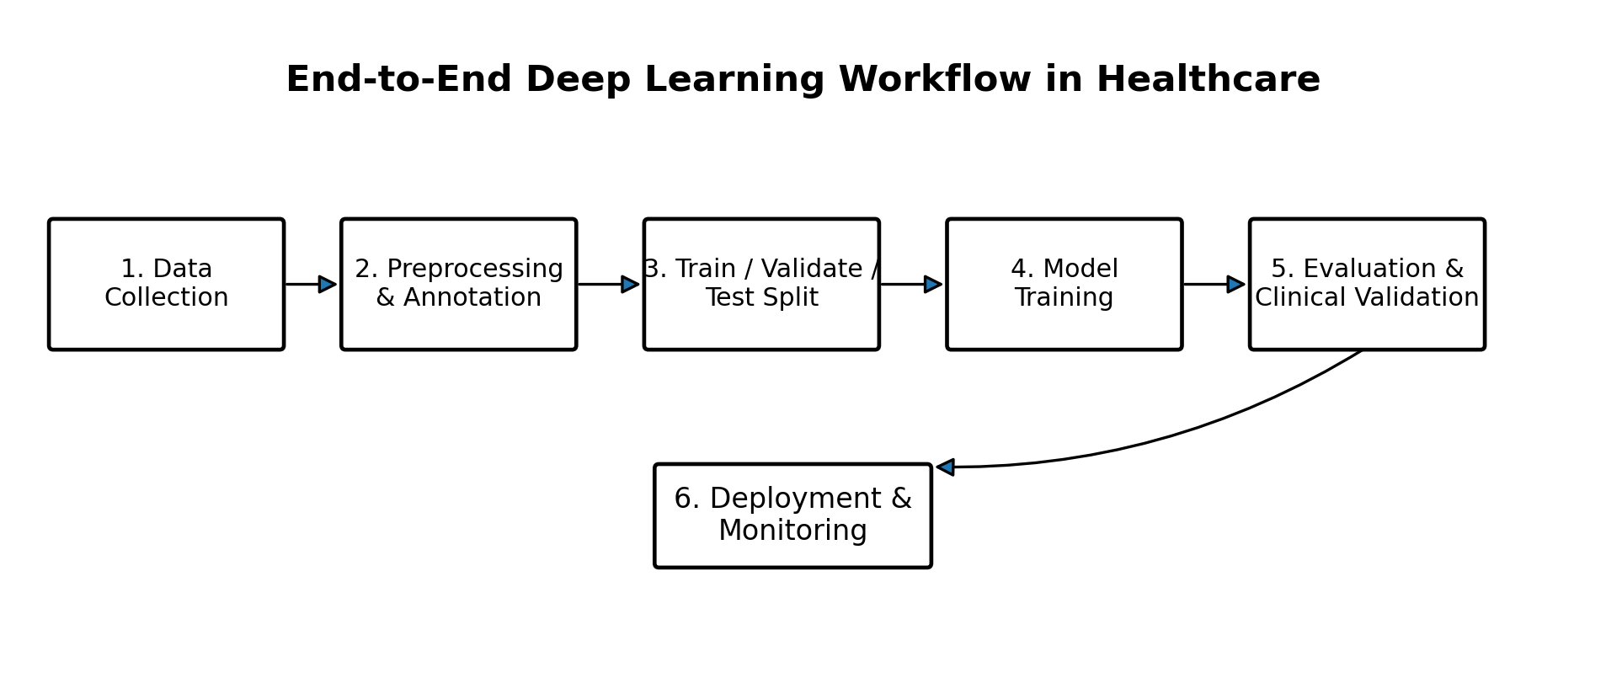
Figure 4. End-to-end workflow for a healthcare deep-learning system.
- Data collection: acquire representative and appropriately governed healthcare data.
- Annotation: use suitable expert or validated labels where required.
- Preprocessing: normalize, resize, clean and prepare data while avoiding information leakage.
- Dataset split: separate training, validation and test data appropriately.
- Training: optimize the model using the training data.
- Validation: tune model choices and monitor overfitting.
- Testing: evaluate on held-out data using suitable metrics.
- Clinical validation: assess usefulness, safety, generalization and workflow fit.
- Deployment and monitoring: monitor performance, drift, false alarms and unexpected behavior.
15. MAJOR APPLICATIONS OF DEEP LEARNING IN HEALTHCARE
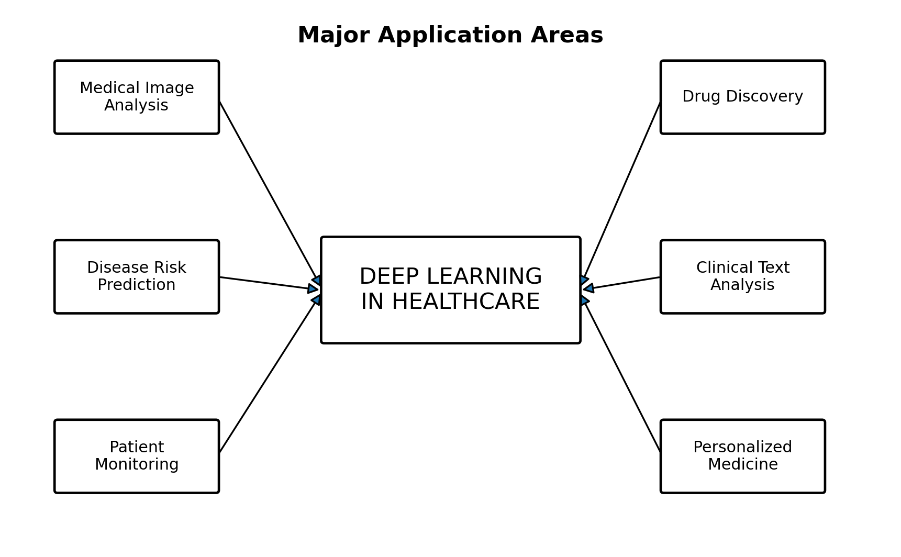
Figure 5. Major application areas of deep learning in healthcare.
Application | Typical Data | Possible DL Approach | Expected Support
Medical imaging | X-ray, CT, MRI, pathology | CNN / Vision models | Classification, detection, segmentation
Risk prediction | EHR, labs, demographics | DNN / Transformer | Risk stratification
Patient monitoring | ECG, sensors, time series | LSTM / Transformer | Trend and event detection
Drug discovery | Molecules, biological data | DNN / GNN / Transformer | Candidate prioritization
Clinical text | Notes, reports | Transformer | Information extraction / retrieval

16. CNN ARCHITECTURE – EXPLANATION
- Input layer receives an image such as an X-ray or MRI slice.
- Convolutional layers apply learnable filters to extract local patterns such as edges, textures and shapes.
- Activation functions such as ReLU introduce non-linearity.
- Pooling layers reduce spatial dimensions and retain important features.
- Deeper layers learn increasingly abstract representations.
- Fully connected or task-specific layers convert learned features into predictions.
- A final output layer may provide class probabilities for classification.
17. COMPARISON OF DEEP LEARNING MODELS
Model | Strength | Typical Data | Healthcare Use | Limitation
CNN | Spatial feature learning | Images | X-ray/CT/MRI analysis | Needs suitable image data
RNN/LSTM | Sequential patterns | Time series | Patient monitoring | Can be harder to train on long sequences
Transformer | Long-range relationships | Text / multimodal | Clinical NLP and multimodal AI | Often computationally demanding
Autoencoder | Representation learning | Images/signals | Denoising, compression, anomaly detection | Reconstruction objective may not match clinical task
18. EVALUATION METRICS
- Accuracy: proportion of all predictions that are correct.
- Precision: proportion of predicted positives that are actually positive.
- Recall/Sensitivity: proportion of actual positives detected by the model.
- Specificity: proportion of actual negatives correctly identified.
- F1-score: harmonic mean of precision and recall.
- ROC-AUC: summarizes ranking/discrimination performance across classification thresholds.
- For medical segmentation, metrics such as Dice coefficient and IoU are commonly considered.
19. DATA PRIVACY, BIAS AND ETHICS
- Patient data must be handled according to applicable privacy, security and institutional requirements.
- Training data should represent relevant populations to reduce systematic bias.
- Models should be evaluated for subgroup performance where appropriate.
- Explainability can help clinicians understand model behavior, although explanations should not be treated as proof of correctness.
- Clinical validation is essential before using a model in a real patient-care workflow.
- Human oversight is important, especially for high-impact medical decisions.

20. FINAL COMPARISON – INITIAL VS REFINED OUTPUT
Criterion | Initial Output | Refined Output
Focus | General overview | Focused healthcare applications
Technical depth | Basic | CNN, RNN/LSTM, Transformers
Applications | Mentioned | Explained individually
Workflow | Not included | Complete data-to-deployment workflow
Examples | Few | Practical examples included
Challenges | Brief | Detailed technical and ethical challenges
Structure | Short paragraph | Academic multi-section format
Evaluation | Not included | Metrics and validation discussed
Academic suitability | Moderate | High
21. RESULT
The initial prompt generated a general response, whereas the refined prompt produced a more structured and technically detailed response. Prompt refinement improved specificity, relevance, organization and academic usefulness. Hence, the experiment successfully demonstrates how an AI prompt can be iteratively improved to obtain a higher-quality output.
22. LEARNING OUTCOME
- I learned that a vague prompt can produce a generic answer.
- I learned to specify role, audience, scope, constraints and output format.
- I learned to evaluate an AI response before refining the prompt.
- I learned that examples, tables and diagrams can make technical content clearer.
- I learned that AI-generated healthcare content must be checked for accuracy and should not replace professional clinical judgment.
23. VIVA / ORAL QUESTIONS
1. What is prompt engineering?
2. What is the difference between the initial and refined prompt?
3. Why are CNNs suitable for medical images?
4. What is the role of pooling in a CNN?
5. How can RNN/LSTM models be used in healthcare?
6. Why are Transformers useful for clinical text?
7. What is the difference between classification, detection and segmentation?
8. Why is data privacy important in healthcare AI?
9. Why is external/clinical validation necessary?
10. Can an AI model replace a doctor? Why or why not?
24. ONLINE REFERENCES
European Society of Radiology – Deep learning workflow in radiology: how to get started
https://www.myesr.org/ai-blog/deep-learning-workflow-in-radiology-a-primer/
PMC – A review of deep learning in medical imaging: Imaging traits, technology trends, case studies with progress highlights, and future promises
https://pmc.ncbi.nlm.nih.gov/articles/PMC10544772/
PMC – Convolutional neural networks in medical image understanding: a survey
https://pmc.ncbi.nlm.nih.gov/articles/PMC7778711/
PMC – Applications of Deep Learning Techniques in Healthcare Systems: A Review
https://pmc.ncbi.nlm.nih.gov/articles/PMC12478783/
PubMed – Recent advances and clinical applications of deep learning in medical image analysis
https://pubmed.ncbi.nlm.nih.gov/35472844/
25. NOTE ON DIAGRAMS
The diagrams in this experiment are clean academic redraws based on the concepts and workflows described in the cited online literature. They are intentionally simplified so that the student can understand, explain and reproduce the diagrams during an examination or viva.

